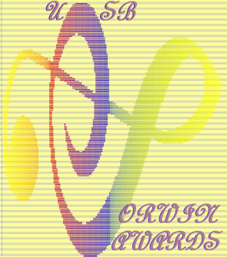

Corwin Awards 2023 Candidate Submission Form
Name: _______________________________________ Date: ____________________
Address: _______________________________________________________________
City/State/Zip: __________________________________________________________
Phone: ___________________________ Email: _______________________________
UCSB Status: _____________________ Major:_______________________________
Title of Piece: ___________________________________________________________

Please check ONE category:
- Work for Large Ensemble
- Solo or Chamber Ensemble Work
- Electronic/Audiovisual Work
- Work for Special Category (acousmatic)
Link to download all materials:

This form must be submitted as a pdf file to: jppo@ucsb.edu

Deadline: 4:00 p.m., March 15th, 2023
Please indicate in the email subject: Corwin Awards 2023

